**Lab 5: NAT**

University of Windsor

Department of Electrical and Computer Engineering

ELEC 8560 – Computer Networks

Semester: Fall 2023

**Student Name**: Amey Mahendra Thakur

**Student number**: 110107589

**Answers:**

1. Client IP Address sending HTTP GET request: **192.168.10.11**

Source Port Number of TCP segment for HTTP GET request: **53924**

Destination IP Address for HTTP GET request: **138.76.29.8**

Destination Port Number of TCP segment for HTTP GET request: **80**

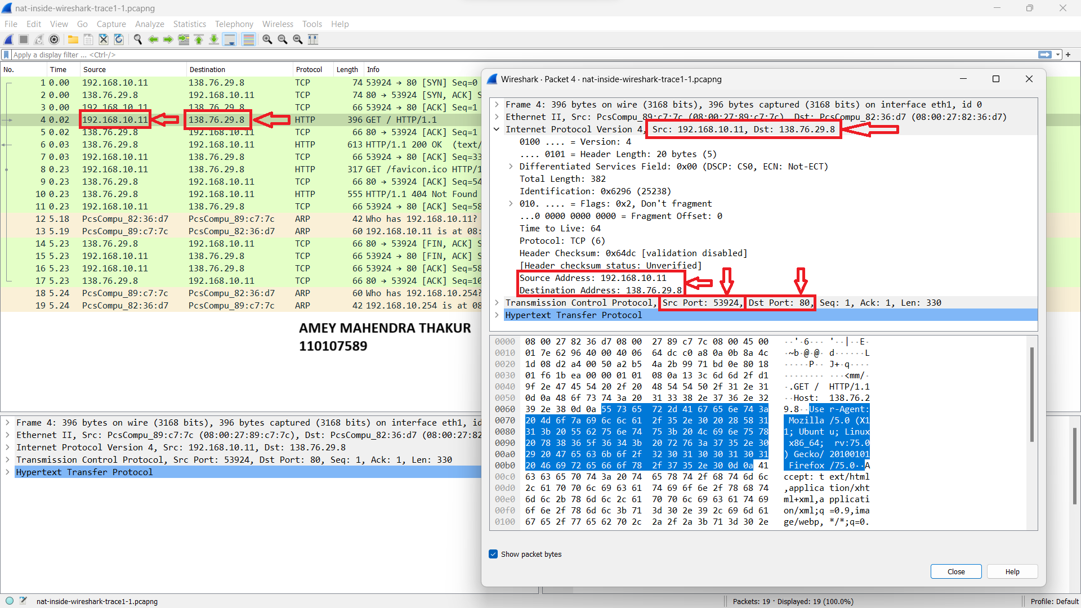

1. The NAT router forwards the HTTP 200 OK message from the webserver to the client on the router's LAN side at approximately **0.030672101 seconds** into the trace, measured from the first captured packet.

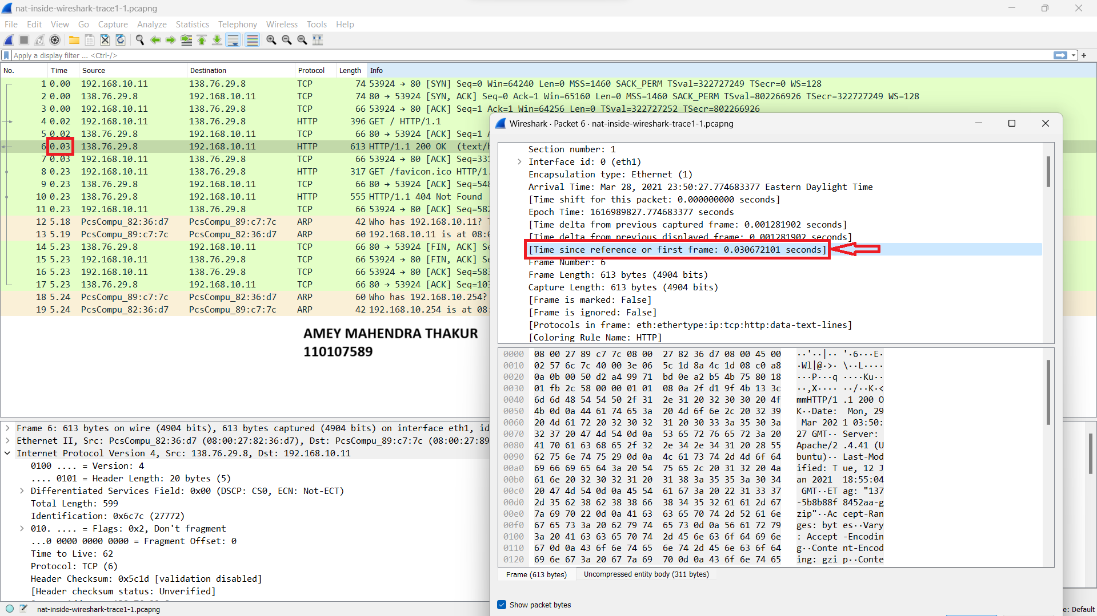

1. IP Datagram for HTTP 200 OK Message:

* Source IP/Port: **138.76.29.8 / 80**
* Destination IP/Port: **192.168.10.11 / 53924**

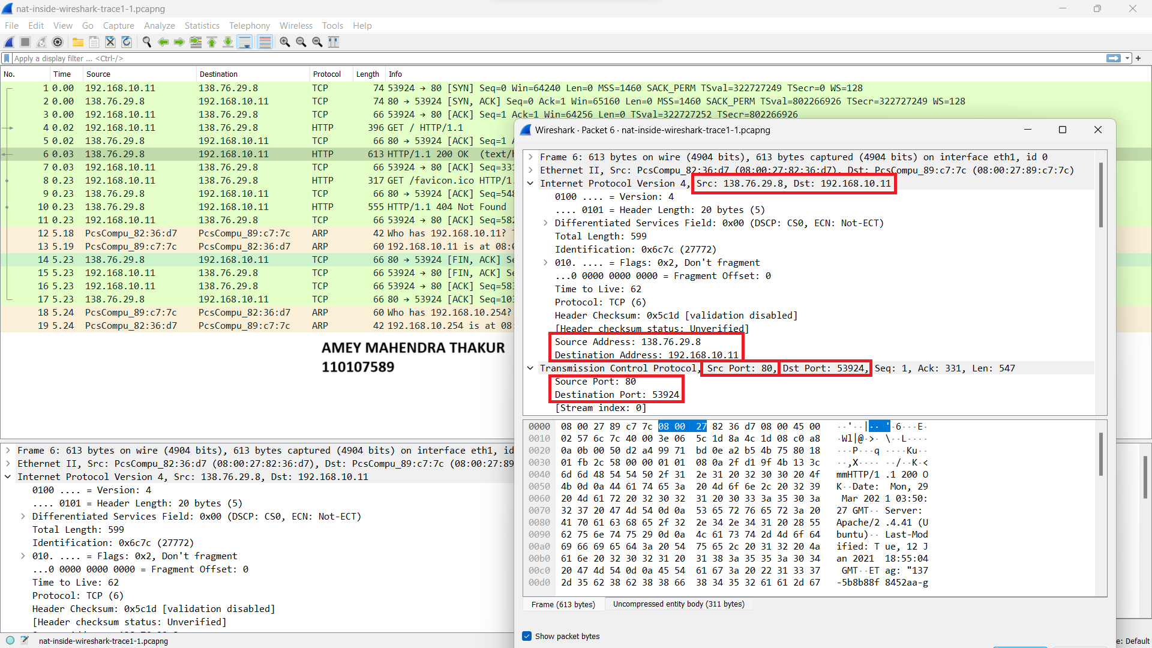

1. Time of Appearance of HTTP GET Message: The HTTP GET message appeared in the nat-outside-wireshark-trace1-1.pcapng trace file at around **0.027356291 seconds.**

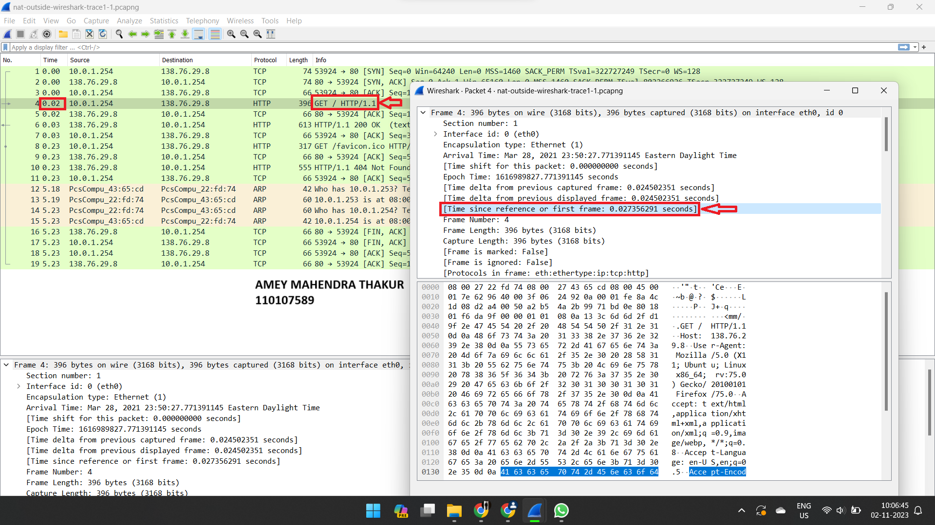

1. IP Datagram for HTTP GET Message in nat-outside-wireshark-trace1-1.pcapng:

* Source IP/Port: **10.0.1.254 / 53924**
* Destination IP/Port: **138.76.29.8 / 80**

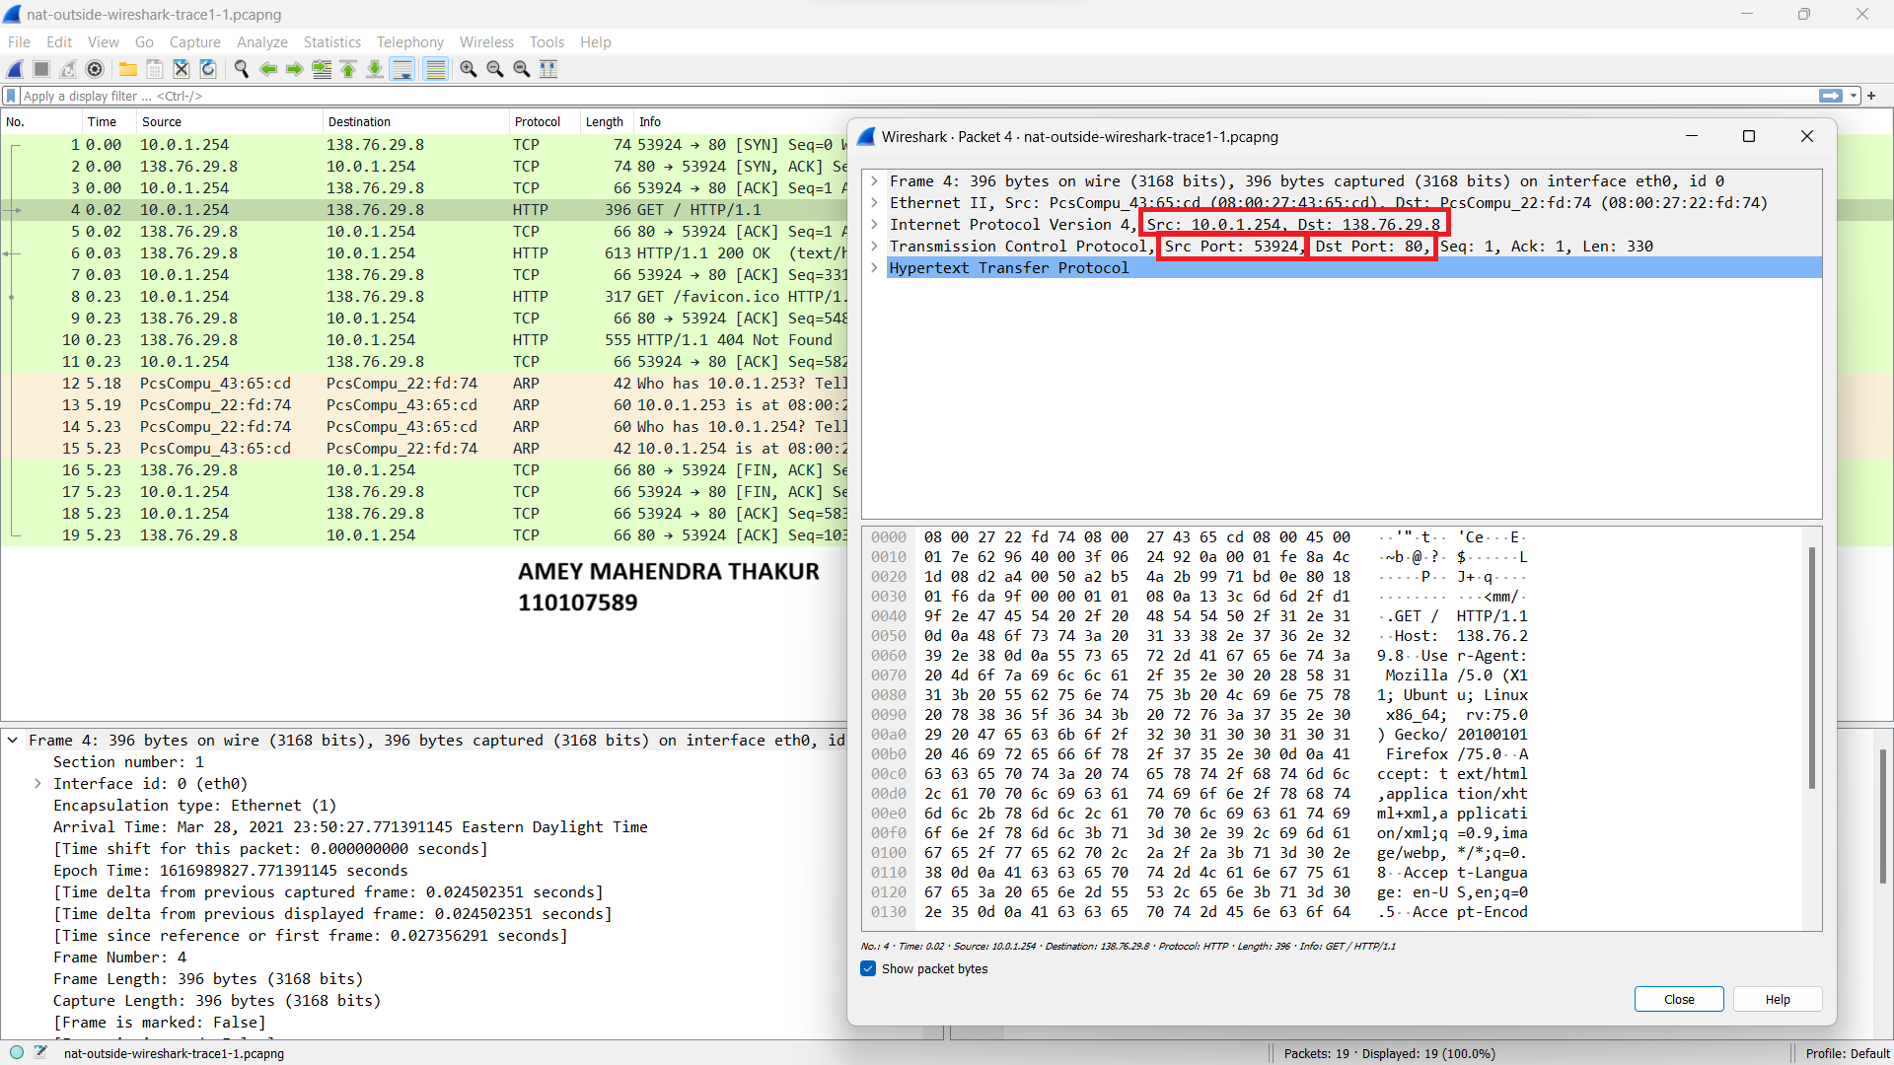

1. When comparing the HTTP GET messages from both files, the only difference I observed among the SRC IP, DST IP, SRC Port, and DST Port fields is that the **SRC IP address is different in both instances**.

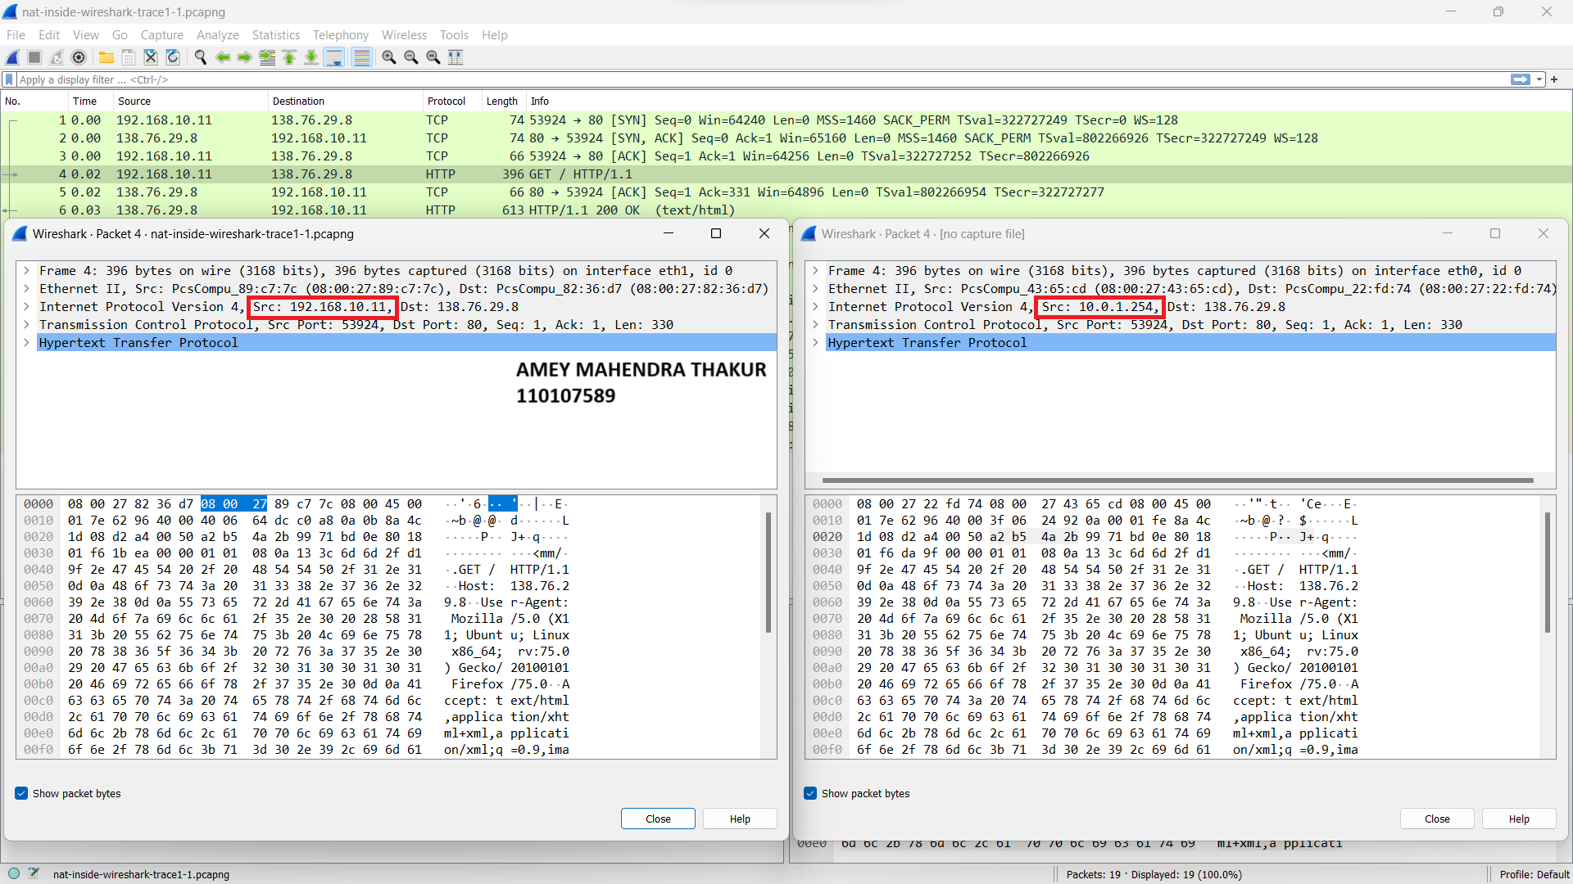

1. In addition to the previously mentioned change in the source IP address, there is also a modification in both the **source and destination MAC addresses** within the Ethernet datagram.

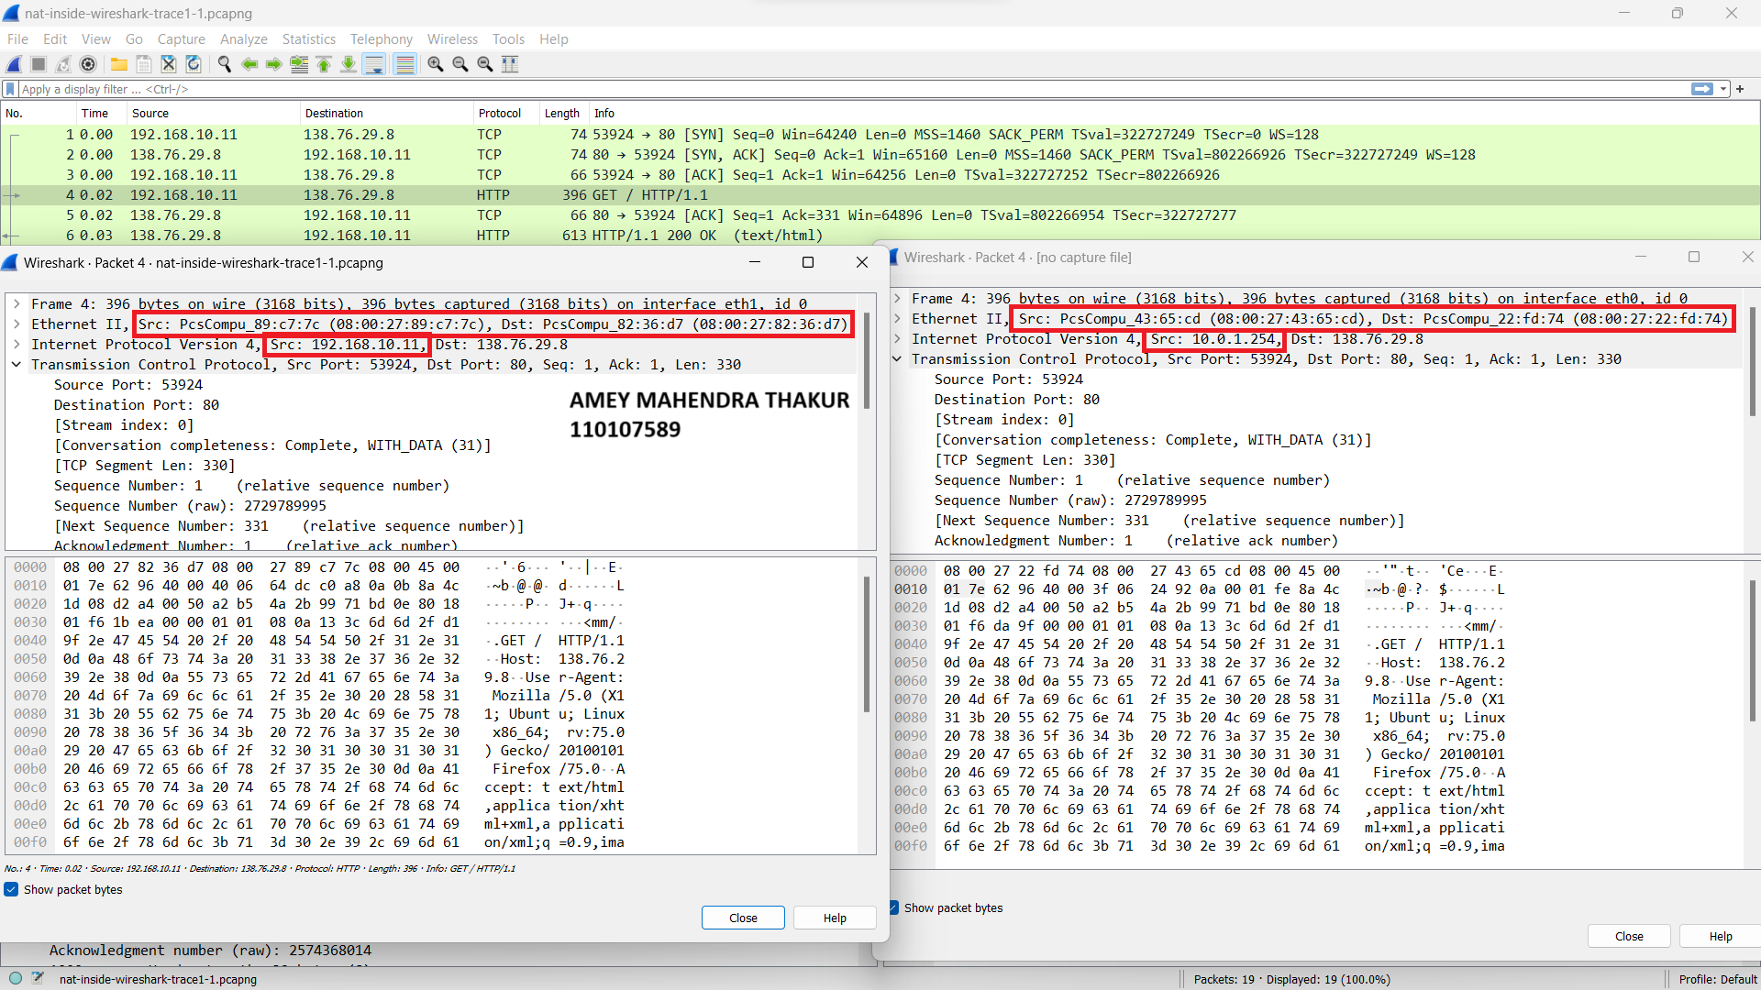

1. In the IP datagram carrying the HTTP GET, the Version, Header Length, and Flags fields remain consistent when comparing the datagram received on the local area network (inside) to the corresponding datagram forwarded on the Internet side (outside) of the NAT router. However, there is a difference in the **Header Checksum value between the two instances.**

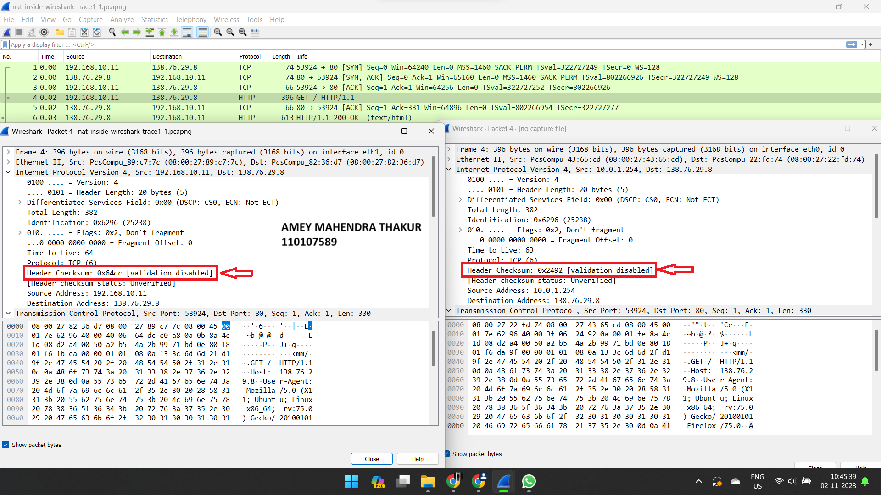

1. Time of Appearance of HTTP OK Message: The HTTP OK message appeared in the nat-outside-wireshark-trace1-1.pcapng trace file at around **0.030625966 seconds.**

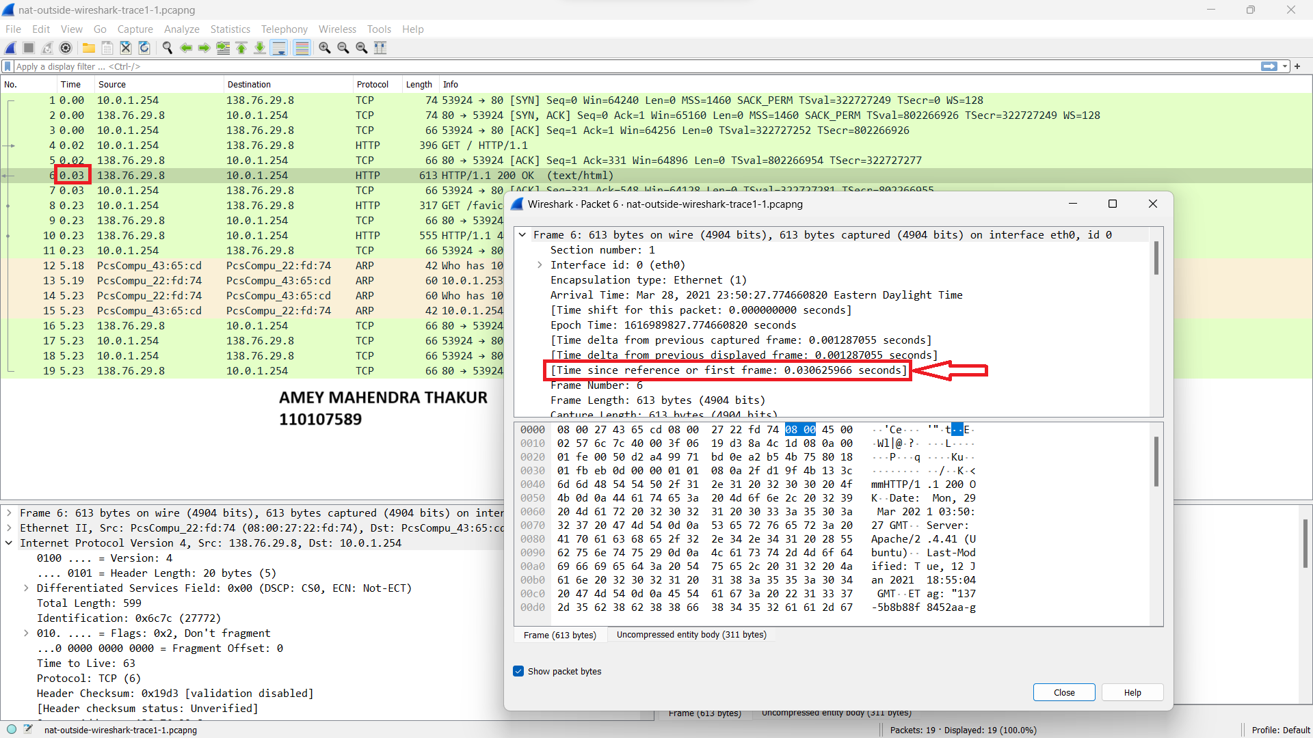

1. IP Datagram for HTTP Reply ("200 OK") Message in nat-outside-wireshark-trace1-1.pcapng:

* Source IP/Port: **138.76.29.8 / 80**
* Destination IP/Port: **10.0.1.254 / 53924**

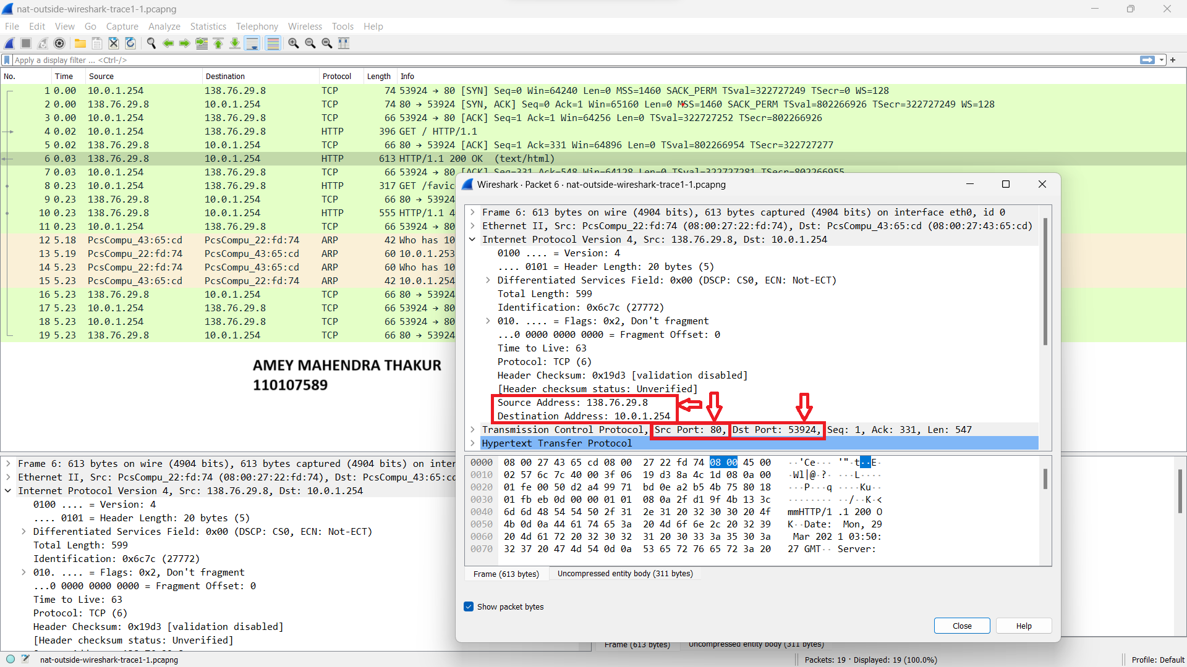

1. IP Datagram for HTTP Reply ("200 OK") Forwarded to Destination Host:

* Source IP/Port: **138.76.29.8 / 80**
* Destination IP/Port: **192.168.10.11 / 53924**

